LED SPIDER LIGHT
M-YL8-10-4 IN 1

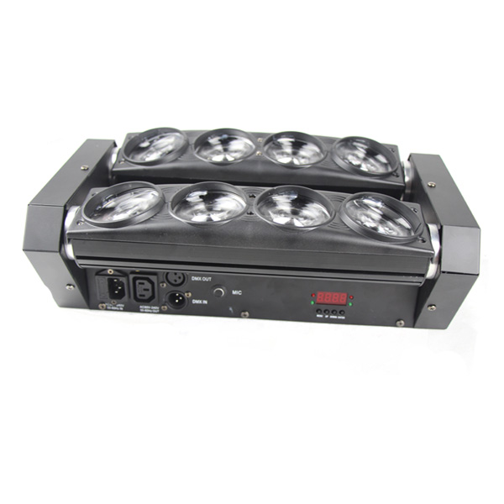

INSTRUCTION MANUAL

Thank you for choosing our LED spider light. For the sake of your safety, Please read and follow these instructions carefully and keep this manual in a safe place for future reference
Menu：
DMX SLAV

MAST Menu down up Enter SOUN
Use button switch and LED display, can set the address code and function code easily.
Check or modify lighting function settings, Press the MENU button. LED display panel will display function menu of lighting. Function operation menu all have corresponding submenu. Each menu all represent the specific functions of lamps, specific see below "operation menu" section.
Technical Parameters:
Voltage: AC90V-240V; 50/60Hz
Power Consumption: 100W (220V)
LED Bulbs: 10W*8LEDs 4in1 LED
LED Current: 1800mA . LED Lifetime: 50000Hours
DMX Channel: 10/36CH
Adjusts the light: 0-100 electron adjusts the light
Strobe: 1-25/second high speed strobe
Head Movement: Tilt 180°, Beam Angle: 6°
Control mode: DMX 512, Stand –alone mode, Self-test mode, Sound, Master/slave
Control Panel: LED display panel
IP Grade: IP33
Work Environment Temperature: -20°C~40°C
Net weight:7.5KG Gross Weight: 8.8 kg
Package Size: 73 x 30x 19cm

Menu Function Description：
ADD | DMX Address | 001 - 512
CHND | Channel choose | 10CH / 36CH
SLND | NAST/SL1/SL2 | Master-slave mode
SHND | Sound effect | SH0 –SH24
SOUN | Sound model | 000 - 100
SENS | Sound sensitivity | Yes - No
BLND | Break mode of turn on | Yes - No
LED | LED display | On - Off
DISP | Display reverse | Yes - No
1TLT | Tilt 1 reverse | Test
2TLT | Tilt 2 reverse | Reset
TEST | Test mode | Test
FHRS | The time of running | ***hours
VER | Program Version | *****
REST | Reset | Yes - No
Note: When the light turn on, LED display show *****LED-SPIDER-BEAM*****
Keeping The Product Clean:
To ensure the reliability of the projector, it should be kept clean. It is recommended that the fans should be cleaned every 15 days. LED lens should also be regularly cleaned to maintain an optimum light output.
Cleaning frequency depends on the environment in which the fixture operates: damp, smoke or particularly dirty surroundings can cause greater accumulation of dirt on the unit's optics. A soft cloth and typical glass cleaning products should be used for cleaning. It is recommended to clean the external optics at least once every 15 days.
☆Do not use any organic solvent, e.g. alcohol, to clean housing of the apparatus.

Trouble Shooting:
Problem | Answer
The LED moving head light doesn’t switch on. | Check the fuse the power socket
Although shines, but the LED moving head lamp doesn’t accept the instruction of the controller. | Check the digital start address and also check the connection situation of the communication control line
LED moving head lamp only can work  intermittently. | Inspect the power supply and voltage is whether normal.
Do not receive the DMX512 signal. | Whether the signal lines do contact  well or broken.
The light beam appears gloomily. | Check that the heat dissipation system is running normally or Inspect the optics part is whether clean.

☆Other maintain work should by the specialist which has the experience to carry on.

Channel List:
10CH mode:
Channel | Function | Value
CH1 | Tilt 1 | 0-255
CH2 | Tilt 2 | 0-255
CH3 | Main dimming | 0-255
CH4 | strobe | 0-255 Speed from slow to fast
CH7 | Red dimming | 0-255
CH8 | Green dimming | 0-255
CH9 | Blue dimming | 0-255
CH10 | White dimming | 0-255
CH5 | Macro (Built-in effect program ) | 0-255
CH6 | Macro speed | 0-255 Speed from fast to slow
36CH mode:
Channel | Function | Value
CH1 | Tilt 1 | 0-255
CH2 | Tilt 2 | 0-255
CH3 | Main dimming | 0-255
CH4 | strobe | 0-255 Speed from slow to fast
CH5 | R1 dimming | 0-255
CH6 | G1 dimming | 0-255
CH7 | B1 dimming | 0-255
CH8 | W1dimming | 0-255
CH9 | R2 dimming | 0-255
CH10 | G2 dimming | 0-255
CH11 | B2 dimming | 0-255
CH12 | W2 dimming | 0-255
CH13 | R3 dimming | 0-255
CH14 | G3 dimming | 0-255
CH15 | B3 dimming | 0-255
CH16 | W3 dimming | 0-255
CH17 | R4 dimming | 0-255
CH18 | G4 dimming | 0-255
CH19 | B4 dimming | 0-255
CH20 | W4 dimming | 0-255
CH21 | R5 dimming | 0-255
CH22 | G5 dimming | 0-255
CH23 | B5 dimming | 0-255
CH24 | W5 dimming | 0-255
CH25 | R6 dimming | 0-255
CH26 | G6 dimming | 0-255
CH27 | B6 dimming | 0-255
CH28 | W6 dimming | 0-255
CH29 | R7 dimming | 0-255
CH30 | G7 dimming | 0-255
CH31 | B7 dimming | 0-255
CH32 | W7dimming | 0-255
CH33 | R8 dimming | 0-255
CH34 | G8 dimming | 0-255
CH35 | B8 dimming | 0-255
CH36 | W8dimming | 0-255

