INTRODUCTION
LED Four Heads Beam Light

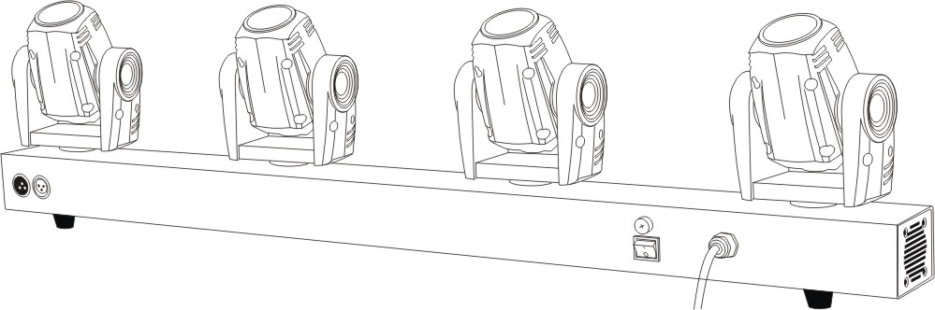

PLEASE READ THIS CAREFULLY BEFORE USE

Thank you for choosing our LED moving head light. For the sake of your safety, please read this manual carefully before use.

I. Installation:
1.This light can work normally between the Voltage of AC90~~240V/50Hz/60Hz.
2. In order to secure the safe installation of the light, always use it in the well-ventilated environment.
3. Always keep this light with a safe distance from any flammable materials.
4. Never install, dismantle and maintain this light when it is powered; and all work aforesaid must be conducted by professionals.
5. Before open the LED moving head and if you want to do the repair work, please make sure the power source is at the separation condition.
6. The packing list of this light is as follows:
- Light-----------------------------------------------1pcs
- Power Cable------------------------------------1pcs
- XLR-----------------------------------------------2pcs
- Bracket-------------------------------------------2pcs
- Screw --------------------------------------------4pcs
- User Manual------------------------------------1pcs

II. Effect:
1. This light can achieve the effect of variable colors and flashing (with speed adjustable)
2. The program of this light can automatically operate, sound, accept DMX512 signal control and be connected for use.

III.Specification：

Voltage: AC100-240V 50/60 Hz
Power: 100W
Light source: 4x10W white LED(Lumiengin LEDs), Color temperature:7000K, 50000 hours of life
DMX channel Mode: 9ch,28 channel international standard channel, 2 channels are convertible
Horizontal scan: 540° (16 bit precision scan)
Vertical scanning: 270° (16 bit precision scan)
Advanced scanning system is more rapid, stable and quiet, has the function of automatic error correction
Dimming: 0-100% linear dimming
Strobe: highest frequency can be 13 times/s
Control mode: Auto, Sound control, master-slave, DMX512
Protective: built-in overheating and trigger the high pressure protection
Show: 8 digital tube display menu
Packing size: 113×33×38cm (2pcs)
N.W:5.5G.W:6.5

VI.Menu:

8 Sub Menu: Enter each operation buttons (Enter) to save
1、 Address code selection A001-A512

2、 X axis inversion of control

3、 Y axis inversion of control

Slave
Sound Control
4、 Master-slave,DMX512 Master Auto program
DMX512
5、 Manual Control, Option 1 ch - 28 ch press Up or Down to adjust the data 0-255
6、 Display positive and negative
7、、 Channel Mode Selection
8、 Reset
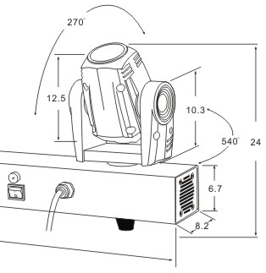

V. Luminous Flux & Body Size:
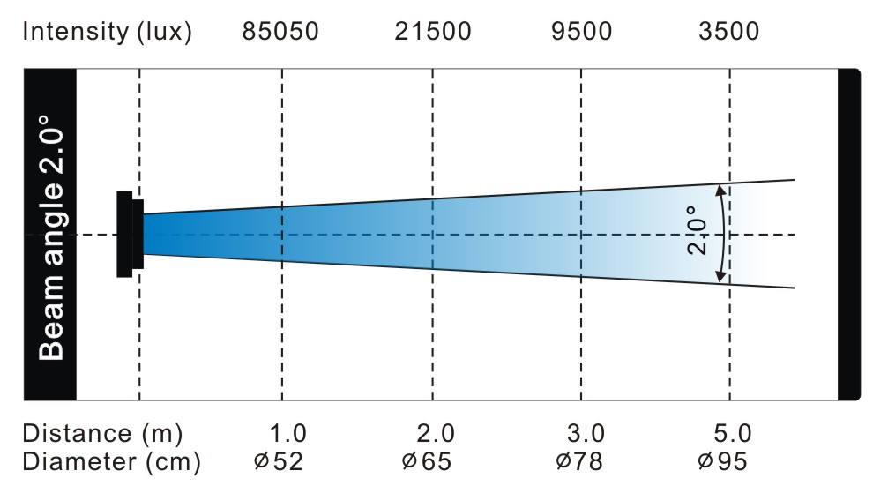

VI.Channel：9 Channels Model:

Item | Channel | DMX | Function
CH1 | X axis | 0-255 | 540°
CH2 | X axis fine | 0-255 | 16bit Precision Scan
CH3 | X axis | 0-255 | 270°
CH4 | X axis fine | 0-255 | 16bit Precision Scan
CH5 | X、Y axis speed | 0-255 | speed from slow to fast
CH6 | Dimming | 0-255 | Brightness from dark to bright
CH7 | Strobe
CH8 | LED Built-in program
CH9 | X、Y Auto program

28 Channels Model:

No | Channel |  | DMX | Function
CH1 | First | X axis | 0-255 | 540°
CH2 | First | X axis fine | 0-255 | 16bit Precision Scan
CH3 | First | X axis | 0-255 | 270°
CH4 | First | X axis fine | 0-255 | 16bit Precision Scan
CH5 | First | X、Y axis speed | 0-255 | speed from slow to fast
CH6 | First | Dimming | 0-255 | Brightness from dark to bright
CH7 | First | Strobe
CH8 | Second | X axis | 0-255 | 540°
CH9 | Second | X axis fine | 0-255 | 16bit Precision Scan
CH10 | Second | X axis | 0-255 | 270°
CH11 | Second | X axis fine | 0-255 | 16bit Precision Scan
CH12 | Second | X、Y axis speed | 0-255 | speed from slow to fast
CH13 | Second | Dimming | 0-255 | Brightness from dark to bright
CH14 | Second | Strobe
CH15 | Third | X axis | 0-255 | 540°
CH16 | Third | X axis fine | 0-255 | 16bit Precision Scan
CH17 | Third | X axis | 0-255 | 270°
CH18 | Third | X axis fine | 0-255 | 16bit Precision Scan
CH19 | Third | X、Y axis speed | 0-255 | speed from slow to fast
CH20 | Third | Dimming | 0-255 | Brightness from dark to bright
CH21 | Third | Strobe
CH22 | Fourth | X axis | 0-255 | 540°
CH23 | Fourth | X axis fine | 0-255 | 16bit Precision Scan
CH24 | Fourth | X axis | 0-255 | 270°
CH25 | Fourth | X axis fine | 0-255 | 16bit Precision Scan
CH26 | Fourth | X、Y axis speed | 0-255 | speed from slow to fast
CH27 | Fourth | Dimming | 0-255 | Brightness from dark to bright
CH28 | Fourth | Strobe

VII.Products warranty card:

Nameof the product:
Item No:
Manufacturing date:
Purchase date:
Final consumer:
Seller：
Company name:
Contact person:
Tel:
Add:

Invoice No:

Stamp

Note: The above blank must be truthfully fill & stamp by the consumer customer and the point-of-sale, or we can refuse to repair. (Warranty & terms, please see as bellows)

1, Warranty: 1 year (calculate from the purchase date).
Warranty terms: 1, If the product goes wrong when use under the normal condition, the repair is free if you can show the warranty card & the copy of the bill to the pointed service center or the factory.

2, During the warranty time, the following case we need to repair with charge,

- Can not show us the effective warranty card.
- Omission or amend or without the name of the point-of-sale on the warranty card..
- The product fails because of the force majeure.
- The product fails because of the transportation or unloading.
- The product fails because didn’t follow the instruction manual,
- Dismantle the products by the non-professional without the permission of the factory.
- The product fails because using the non-factory authorized or non-factory supporting control system.
- Consume goods (lamp)

