120W LED Moving Head Light

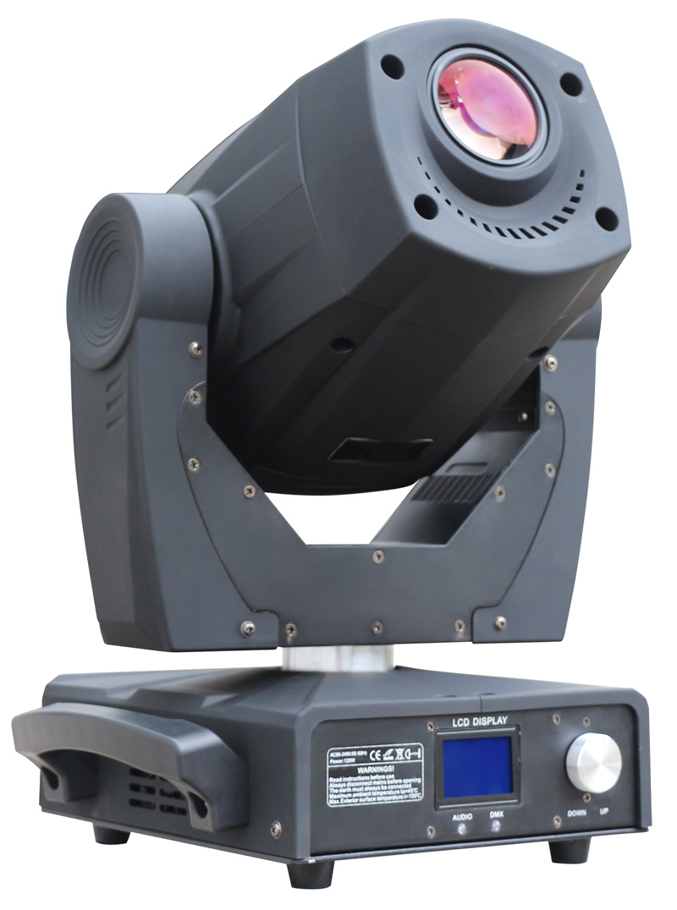

User Manual

Please read the enclosed manual before operating this product
Technical Parameters
 Electrical: Input Voltage 100~240VAC, 50/60HZ
 Light Source: LED Qty 1 x WHITE(120W), Color temperature: 6500k, service life: 50000 hours
 DMX：18channels
 Pan: 540°/360° Tilt: 270° Pan/Tilt: resolution 8-16 bit
 Advanced scanning system is more rapid, stable, peaceful, with automatic error correction of the reset function
 Color wheel: 7 fixed color wheel +white, Half of color effect, color wheel can be arbitrary orientation, with two-way rotation of rainbow effect.
 Static Gobo: 9 Static gobos +white, Include gobo shake
 Rotating Gobo: 7 changeable rotation goboS+white, Include gobo shake
 Prism: 3-facet Rotating prism, two-way rotation and prism positioning function
 Focus: Electronic focus, Smooth adjust the focal length
 Dimmer: 5~100% linear mechanical dimmer
 Strobe: 0-13Hz, Can choose random strobe and pulse frequency strobe
 Dimmer:0-100% linear mechanical dimmer
 Display: LCD display intelligence operations in both English and Chinese
 Protection: built-in overheat and high pressure protection
 Size: 46.5 x 42 x 35cm
 N.W.:13kgs
 G.W.:14kgs
DMX Channel Operations:
Item | Channel | DMX address | Function
CH1 | Dimmer | 0-255 | rom dark to bright
CH2 | Strobe | 0-10 | Off
CH2 | Strobe | 11-39 | On
CH2 | Strobe | 40-240 | Strobe from slow to fast
CH2 | Strobe | 241-255 | On
CH3 | Color | 0-15 | Color 1
CH3 | Color | 16-31 | Color 2
CH3 | Color | 32-47 | Color 3
CH3 | Color | 48-63 | Color 4
CH3 | Color | 64-79 | Color 5
CH3 | Color | 80-95 | Color 6
CH3 | Color | 96-111 | Color 7
CH3 | Color | 112-127 | Color 8
CH3 | Color | 128-191 | Rainbow effect, clockwise from fast to slow
CH3 | Color | 192-255 | Rainbow effect ,anticlockwise from slow to fast
CH4 | Half step of color | 0-255 | Half step of color
CH5 | Pan | 0-255 | 0-540°
CH6 | Tilt | 0-255 | 0-270°
CH7 | Prism | 0-31 | Off
CH7 | Prism | 32-255 | Prism
CH8 | Prism Rotation | 0-127 | Prism fixed position
CH8 | Prism Rotation | 128-191 | Clockwise from fast to slow
CH8 | Prism Rotation | 192-255 | Anti clockwise from slow to fast
CH9 | Rotation Gobo | 0-15 | Gobo 1
CH9 | Rotation Gobo | 16-31 | Gobo 2
CH9 | Rotation Gobo | 32-47 | Gobo 3
CH9 | Rotation Gobo | 48-63 | Gobo 4
CH9 | Rotation Gobo | 64-79 | Gobo 5
CH9 | Rotation Gobo | 80-95 | Gobo 6
CH9 | Rotation Gobo | 96-111 | Gobo 7
CH9 | Rotation Gobo | 112-127 | Gobo 8
CH9 | Rotation Gobo | 128-191 | Rainbow effect, clockwise from slow to fast
CH9 | Rotation Gobo | 192-255 | Rainbow effect, anti clockwise from slow to fast
CH10 | Gobo Rotation | 0-85 | Gobo Rotation t, clockwise from slow to fast
CH10 | Gobo Rotation | 86-170 | Gobo Rotation, anti clockwise from slow to fast
CH10 | Gobo Rotation | 171-178 | Gobo static
CH10 | Gobo Rotation | 179-255 | Gobo shake speed from slow to fast
CH11 | Gobo Angle | 0-255 | Gobo Angle adjust
CH12 | Static Gobo | 0-12 | Gobo 1
CH12 | Static Gobo | 13-25 | Gobo 2
CH12 | Static Gobo | 26-38 | Gobo 3
CH12 | Static Gobo | 39-51 | Gobo 4
CH12 | Static Gobo | 52-64 | Gobo 5
CH12 | Static Gobo | 65-77 | Gobo 6
CH12 | Static Gobo | 78-90 | Gobo 7
CH12 | Static Gobo | 91-103 | Gobo 8
CH12 | Static Gobo | 104-116 | Gobo 9
CH12 | Static Gobo | 117-127 | Gobo 10
CH12 | Static Gobo | 128-191 | Rainbow effect, clockwise from slow to fast
CH12 | Static Gobo | 192-255 | Rainbow effect, anti clockwise from slow to fast
CH13 | Aperture | 0-199 | Aperture Zoom In/Out
CH13 | Aperture | 200-255 | Aperture Zoom In/Out, the speed from slow to fast
CH14 | Focus | 0-255 | Near to far
CH15 | Pan fine | 0-255 | 16bit scanning
CH16 | Tilt fine | 0-255 | 16bit scanning
CH17 | Speed of pan/tilt | 0-255 | Fast-slow
CH18 | Reset | 0-254 | No function
CH18 | Reset | 255 | Reset（5s）

Menu:
There have seven model, Choose menu by pressing ”UP&DWON” button, to confirm by press “ENTER” button
Note: Press “ENTER” button to save each operation

1.DMX Address：
Sets the address code: 001-512

Standard model
1、Control mode
Extension mode
2.Parameters setting

2、Model selection of the light

1、The Pan inversion of control
2、The Tilt inversion of control
3、Pan / Tilt exchange
3.Option 4、The Dimmer reverse channels
5、The Aperture reverse channels
6、The effect of cycle shortest distance
7、Allow DMX reset

1、Display language: Chinese and English
2、Screen brightness: 0-100%
〈1〉Keep bright
4.Display set 3、Backlit Setting 〈2〉Delay darken without operation
〈3〉Delay turn off without operation
4、Show the Logo

5.Manual control: Choose CH1-CH16 adjust the data 0-255

1、Sound control
6.Test run
2、Auto

7.Restore the factory default Settings

8.Rest

